./

GENESIS – Embedded C Learning Report



|  |  |  |  |  |  |
| --- | --- | --- | --- | --- | --- |
| **Ver. Rel. No.** | **Release Date** | **Prepared. By** | **Reviewed By** | **To be Approved** | **Remarks/Revision Details** |
| V1.0 | 02/01/2021 | Shriram M.S |  |  |  |
|  |  |  |  |  |  |
|  |  |  |  |  |  |
|  |  |  |  |  |  |
|  |  |  |  |  |  |

**Details**

**Table of Contents**

1 ACTIVITY 1: PERFORM BUILD USING GIT BASH 4

1.1 EVENODD.C FILE 4

1.2 EVENODD.H FILE 4

1.3 MAIN FILE 5

1.4 SCREENSHOT OF BUILD AFTER RUNNING IN GIT BASH 5

2 ACTIVITY 2: LINKER SCRIPT 5

3 ACTIVITY 3: STARTUP CODE 7

4 ACTIVITY 4: BUILD USING MAKEFILE 8

4.1 SCREENSHOT OF MAKEFILE 8

4.2 SCREENSHOT OF OUTPUT AFTER RUNNING MAKE 8

4.3 OUTPUT FILES CREATED 9

4.4 GITHUB LINK 9

5 MINIPROJECT 9

5.1 SCREENSHOT OF CODE IMPLEMENTATION 9

5.2 GITHUB LINK 9

# ACTIVITY 1: PERFORM BUILD USING GIT BASH

## EVENODD.C FILE

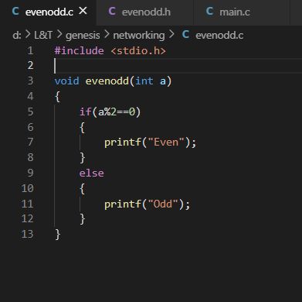

## EVENODD.H FILE

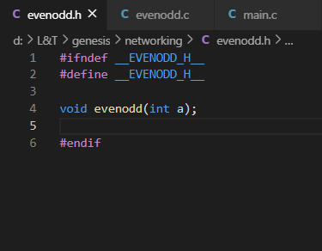

## MAIN FILE

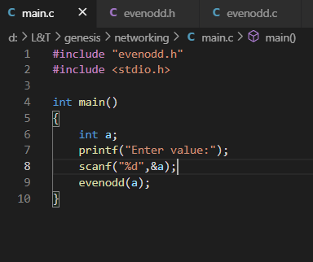

## SCREENSHOT OF BUILD AFTER RUNNING IN GIT BASH

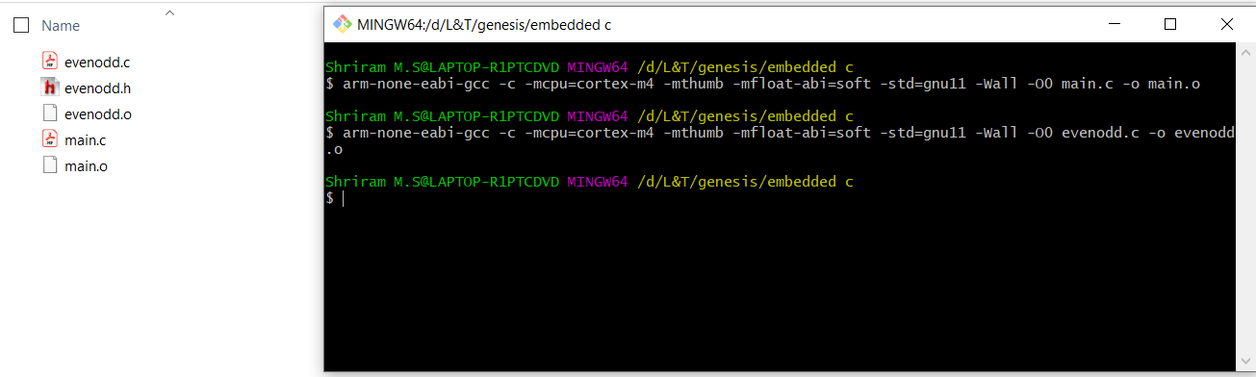

# ACTIVITY 2: LINKER SCRIPT

* The Linker Script is a text file made up of a series of Linker directives which tell the Linker where the available memory is and how it should be used. Thus, they reflect exactly the memory resources and memory map of the target microcontroller.

ENTRY(Reset_Handler)

MEMORY

{

FLASH(rx):ORIGIN =0x08000000,LENGTH =1024K

SRAM(rwx):ORIGIN =0x20000000,LENGTH =128K

}

SECTIONS

{

.text :

{

*(.isr_vector)

*(.text)

*(.text.*)

*(.init)

*(.fini)

*(.rodata)

*(.rodata.*)

. = ALIGN(4);

_etext = .;

}> FLASH

_la_data = LOADADDR(.data);

.data :

{

_sdata = .;

*(.data)

*(.data.*)

. = ALIGN(4);

_edata = .;

}> SRAM AT> FLASH

.bss :

{

_sbss = .;

__bss_start__ = _sbss;

*(.bss)

*(.bss.*)

*(COMMON)

. = ALIGN(4);

_ebss = .;

__bss_end__ = _ebss;

. = ALIGN(4);

end = .;

__end__ = .;

}> SRAM

}

# ACTIVITY 3: STARTUP CODE

# ACTIVITY 4: BUILD USING MAKEFILE

## SCREENSHOT OF MAKEFILE

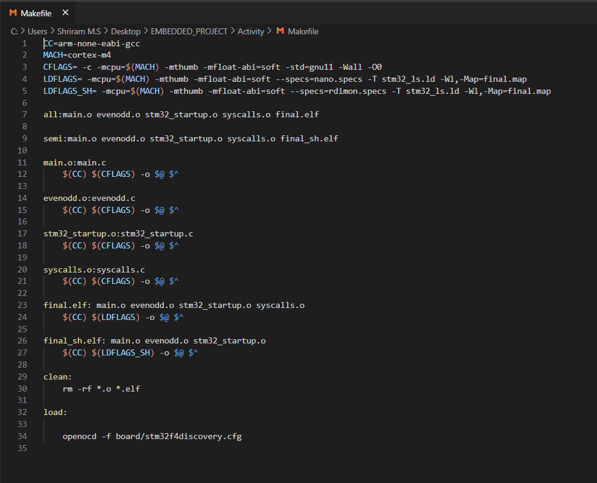

## SCREENSHOT OF OUTPUT AFTER RUNNING MAKE

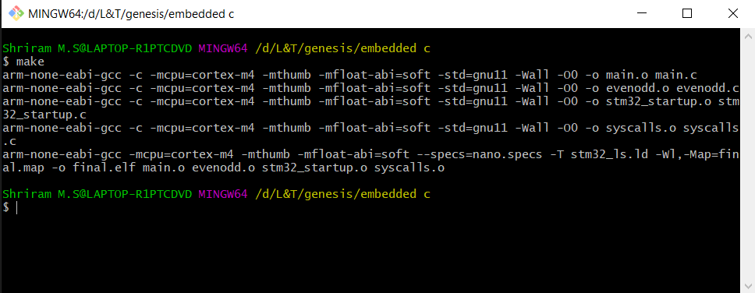

## OUTPUT FILES CREATED

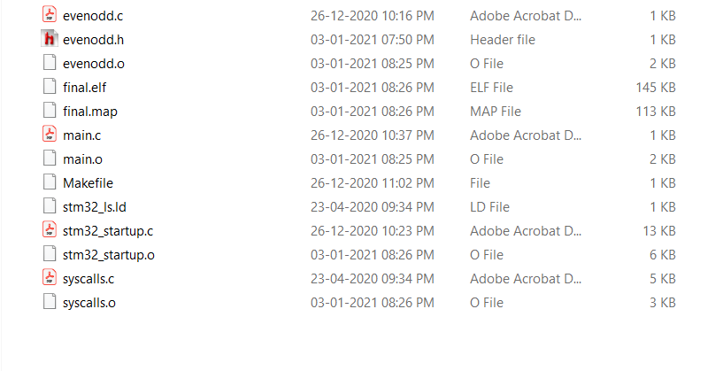

## GITHUB LINK

# MINIPROJECT

## SCREENSHOT OF CODE IMPLEMENTATION

## GITHUB LINK